Git Push and pull

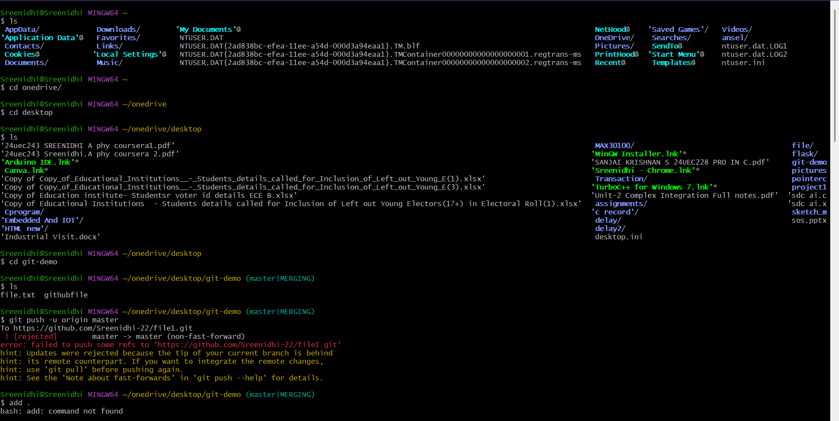

Create github repo and copy remote link

Right click to paste in bash

git push -u origin master – to push the file to central repo

paste the token to connect github

git pull -u origin master – to pull the file to local repo which was created in github

git branch – to check the number of branches

git checkout -b branch name – to create a branch

git checkout branch name – to change the branch

if we modify the file then it is needed to carry out the process from git add .

compare and pull requests from other branch to master branch if ok merge branch.

